**EXP NO: 11 DATE:15-03-24**

**Aim:** To Demonstrate virtualization by Installing Type-2 Hypervisor in your device, create and configure VM image with a Host Operating system (Either Windows/Linux).

**Implementation:**

1.install and setup VM ware software and create a new virtual machine

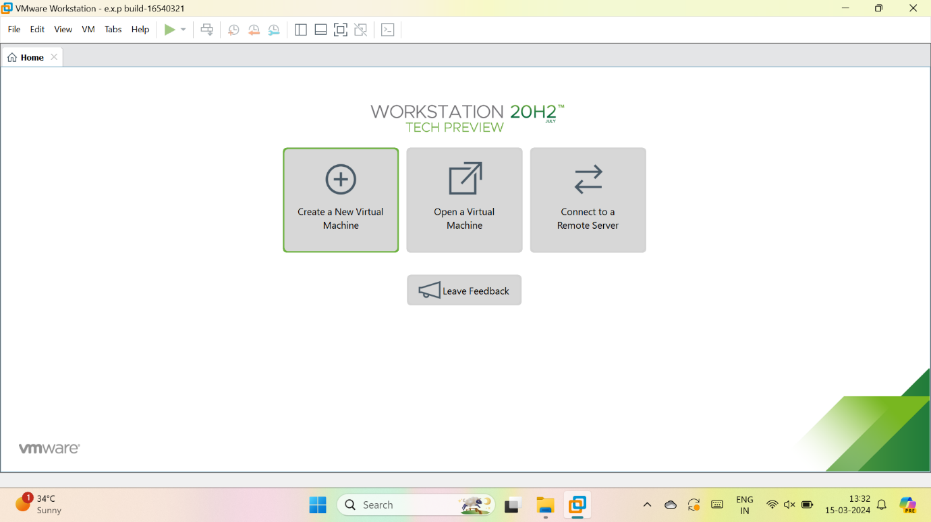

2.select typical

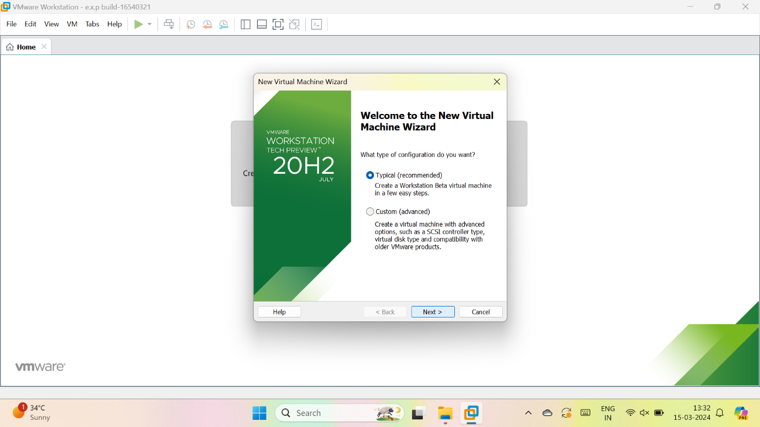

3.we have to select installer disc image and upload image file

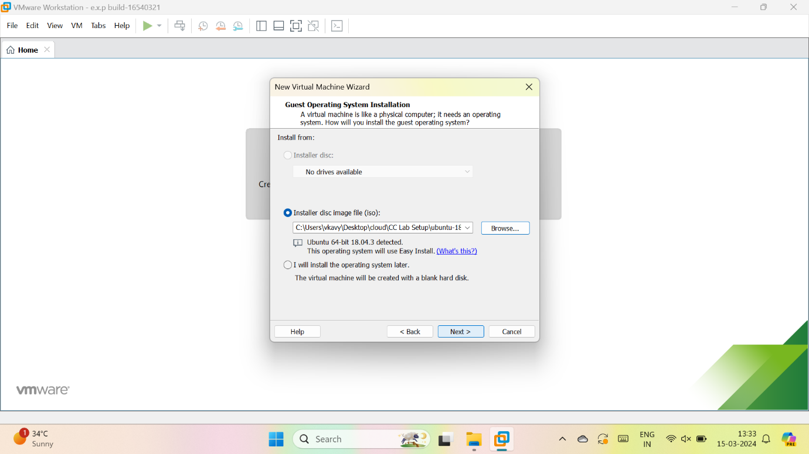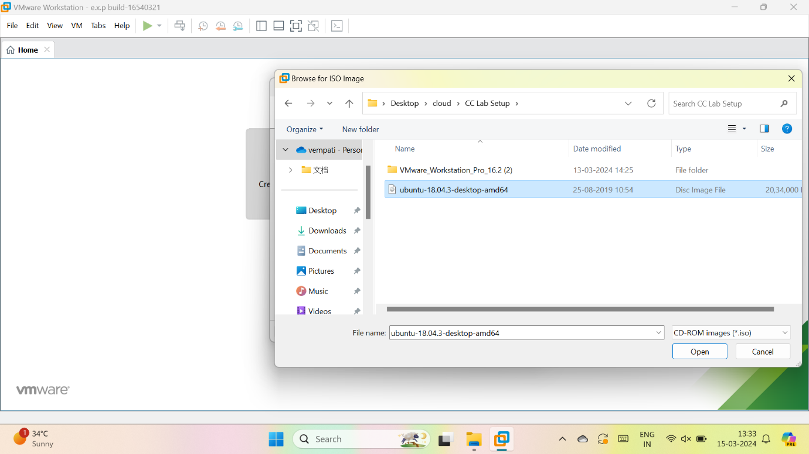

4.give the details for the new os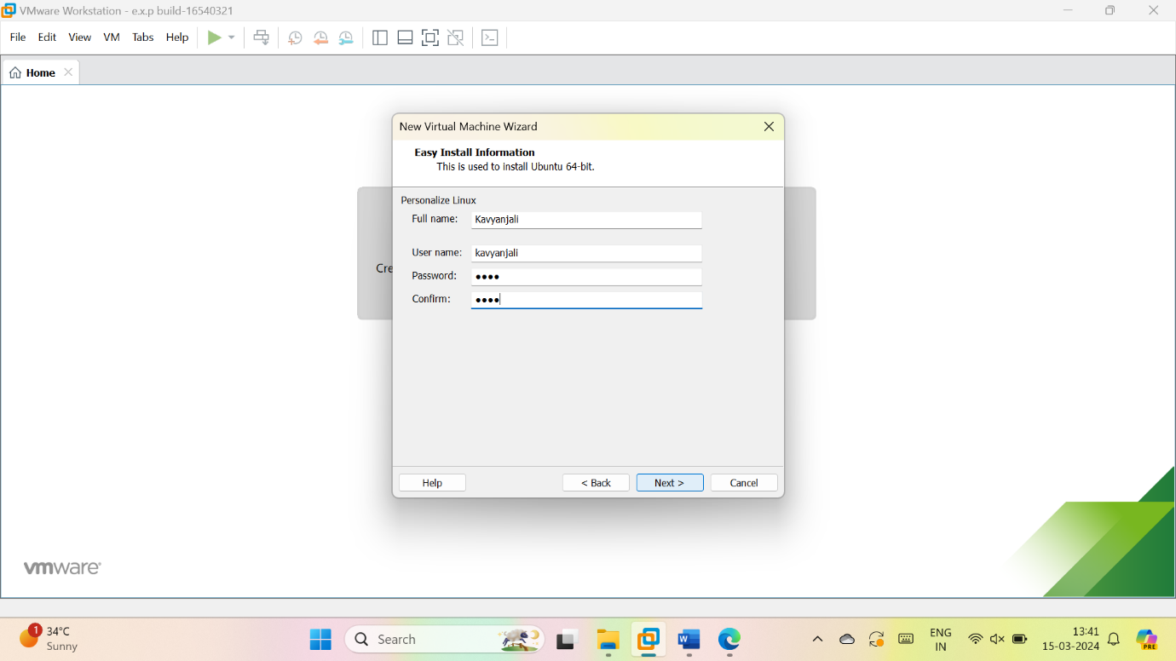

5.give name for VM ware

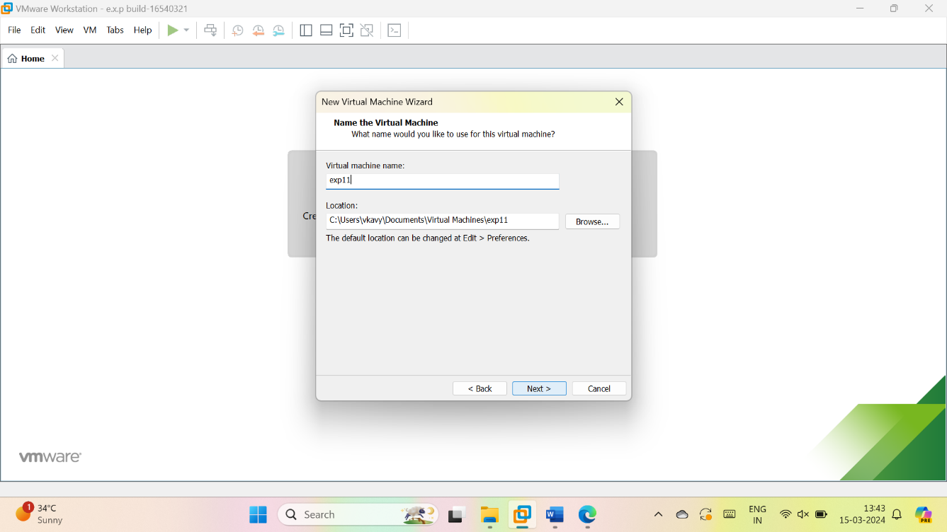

6.give the maximum size of disk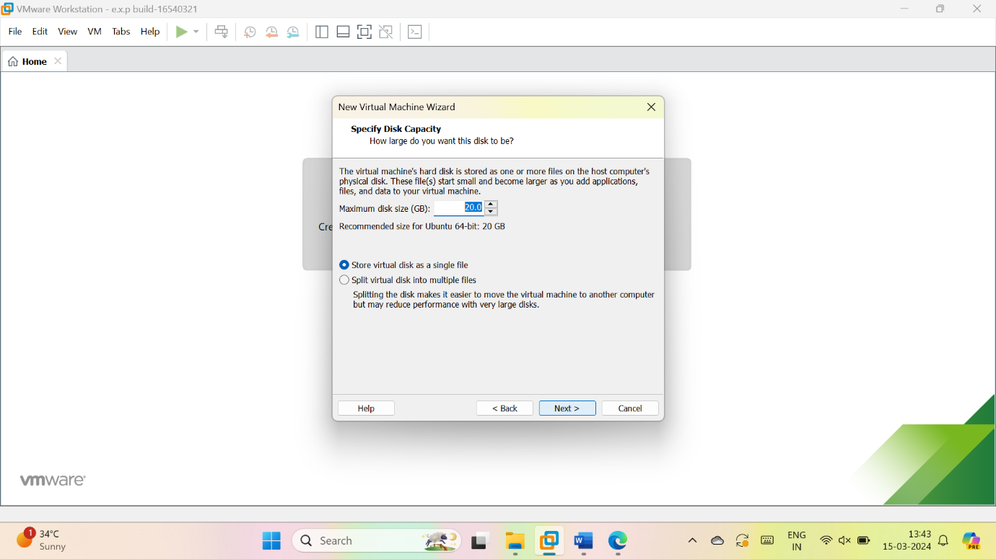

7.check the description

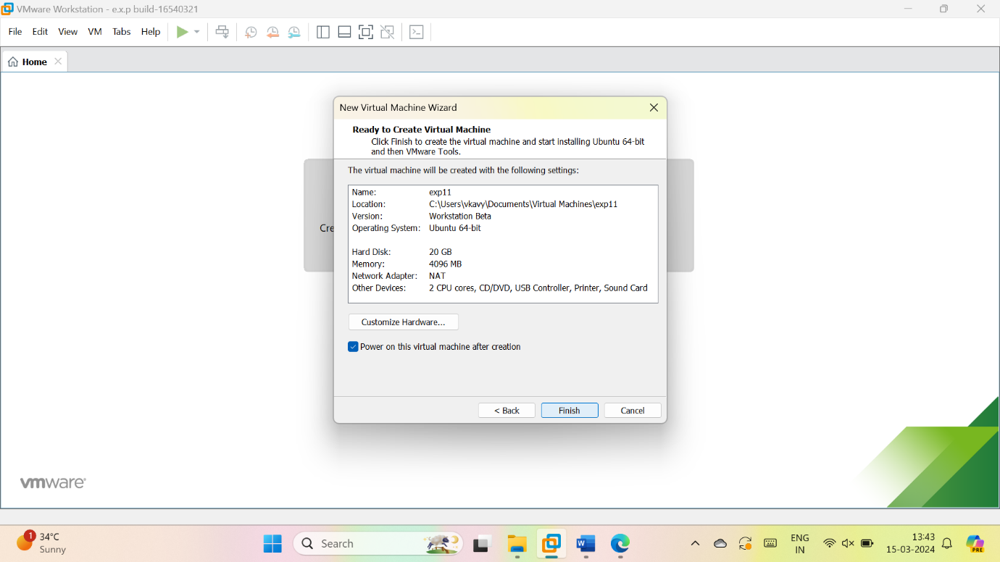

8.if will start loading